EXAMPLE: An assessment of a shallow geothermal reservoir of Mae Chan hot spring, northern Thailand via magnetotelluric surveys
Puwis Amatyakul, Spencer H. Wood, Tawat Rung-arunwan, Chatchai Vachiratienchai, Natthaporn Prommakorn, Pornpan Chanapiwat and Weerachai Siripunvaraporn

Rationale and objective: The country’s need for renewable energy led to the proposed geothermal energy assessment at Mae Chan hot spring using the advanced geophysical exploration. The aim is to reveal the shallow hot water reservoir using the resistivity mapping from 3-D magnetotelluric exploration to accurately locate the testing wells.
Summary: A series of magnetotelluric (MT) surveys from 2013 to 2018 was conducted in order to assess the location, size and depth of the shallow geothermal reservoir of the Mae Chan hot spring. All data were combined to produce the final 3-D resistivity structure. The final MT survey had a high density of MT sites across the zone of interesting which allowed us to precisely image the shallow reservoir for drilling purposes. Using the final MT results, five new boreholes with a maximum depth of 200 m were drilled. Hot water was found at various depths from each borehole with perfect agreement with the final resistivity structure derived from the MT data. This 3-D resistivity outline will be useful in developing the field with future production and re-injection wells.
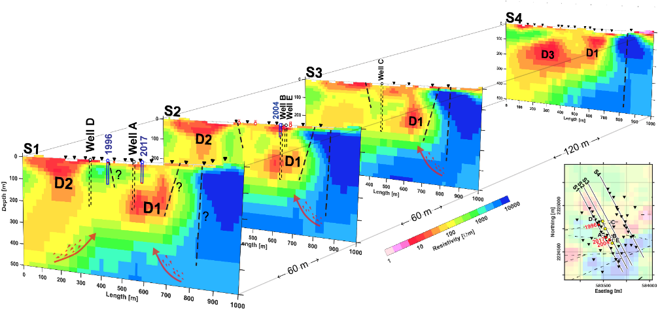
Graphical summary: Resistivity cross sections (S1 - S4) obtained from 3D MT surveys which
were used to guide proposing the drill wells (A, B, C, D and E) for underground hot water.
Outcome: The 3-D resistivity mapping reveals the hydrothermal system with the suggesting location of the shallow hot fluid reservoirs and will be used in geothermal energy assessment.
Research grant and acknowledgement: 1. Department of Alternative Energy Development and Efficiency (DEDE), Ministry of Energy, 2. Thailand Center of Excellence in Physics, Ministry of Higher Education, Science, Research and Innovation
Related SDGs goal: 7. Ensure access to affordable, reliable, sustainable and modern energy for all.
Related publications:
- Amatyakul, P., Rung-Arunwan, T., & Siripunvaraporn, W. (2015). A pilot magnetotelluric survey for geothermal exploration in Mae Chan region, northern Thailand. Geothermics, 55, 31–38. https://doi.org/10.1016/j.geothermics.2015.01.009
- Amatyakul, P., Boonchaisuk, S., Rung-Arunwan, T., Vachiratienchai, C., Wood, S. H. S. H., Pirarai, K., Fuangswasdi, A., & Siripunvaraporn, W. (2016). Exploring the shallow geothermal fluid reservoir of Fang geothermal system, Thailand via a 3-D magnetotelluric survey. Geothermics, 64, 516–526. https://doi.org/10.1016/j.geothermics.2016.08.003

